**Project Report**

**Saranya Pandiaraj (015304497)**

***Data 230 Data Visualization***

**Department of Applied Data Science**

**San Jose State University**

**Section 11, Spring 2021**

Futuristic Airbnb – Exploring in London

**Project Details**

|  |  |
| --- | --- |
| **Name** | Saranya Pandiaraj |
| **Student ID** | 015304497 |
| **GitHub ID** | SaranyaPandiaraj |
| **Project GitHub Link** | https://github.com/SaranyaPandiaraj/Futuristic_Airbnb-Exploring_in_London |

**Project Goal**

The main goal of this project is to design an Interactive dashboard using data visualization tools (Tableau) from the publicly available London Airbnb dataset.

**Table of Contents**

Abstract 3

**Introduction & Motivation** 4

**Project Deliverables** 5

**Data Set Overview** 7

Data Set Resources 7

Data Set Description 7

Dataset features 8

Sample Dataset 10

**Data Cleaning** 12

Determining the Null Value data 12

Dropping the features 13

Converting the Categorical features to Continuous 13

Dropping Similar Kind of Columns 15

Replacing Similar kind of Column values 16

Changing the Data Types 20

Removing special characters 20

Dropping Duplicates 20

Dashboard Visualization 21

Takeaways 35

Conclusion & Future Work 35

References 35

# Abstract

# **Introduction & Motivation**

Airbnb is a vacation rental platform where the user can rent a home for tourism experiences. User can also list their properties in Airbnb for renting it out. Airbnb can see an exponential increase in the number of rentals listed on their platform every year. The platform has attracted more people with their home friendly services and hospitality. Thus, feels like staying in a home even on a vacation.

London is the most popular place having around 76534 listings as of December 16, 2020. Around 40% of their listings with the entire home types are being rented out to the tourists for more than 90 days term. On an average term, Airbnb guests stay for around an average of 4.5 nights in London.

The main purpose of this project is to analyze and visualize the Airbnb dataset. Our investigation will help us to determine the factors for the success of Airbnb business; places to explore for the hosts to expand the Airbnb business; covid impacts on Airbnb; listings managed by the hosts; Renting prices based on the accommodates; judging the host response rate; forecasting/predicting the listing price over the time; availability frequency; etc. To visually analyze the data, we will be creating an interactive dashboard & stories using Tableau. This dashboard will be helpful for the user to find a better accommodation based on customer satisfaction & requirements. And, will also help in improving the Airbnb business based on certain factors in London.

# **Project Deliverables**

|  |  |  |  |  |  |  |
| --- | --- | --- | --- | --- | --- | --- |
| Sr No. | Deliverable  Name | Deliverable  Description | Start Date | End Date | Status | Notes |
| 1 | **Requirement Gathering** | Project Goals - What needs to be done? | 02/01/2021 | 02/02/2021 | Completed |  |
| 2 | **Data Set Exploration** | Identifying & Understanding the Data Sets | 02/03/2021 | 02/08/2021 | Completed |  |
| 3 | **Project Proposal** | Project Abstract – What is to be done? - Research questions | 02/09/2021 | 02/11/2021 | Completed |  |
| 4 | **Data Extraction & Clean-up** | Cleaning up unnecessary data from the dataset | 02/22/2021 | 03/31/2021 | Completed | Includes of Coding work |
| 5 | **Final Data Analysis** | Data Transformation  (Any Logics to be applied) | 02/22/2021 | 03/31/2021 | Completed | Includes of Coding work |
| 6 | **Data Visualizations**  **(Includes of Creating Stories & Dashboards)** | Listing Visualizations | 04/01/2021 | 05/13/2021 | Completed | Parallel Work on Visualization  (plus coding work) |
| Host Visualizations | 04/01/2021 | 05/13/2021 | Completed |
| Reviews Visualizations | 04/01/2021 | 05/13/2021 | Completed |
| 7 | **Outcomes** | Take Away from the dashboards | 05/01/2021 | 05/13/2021 | Completed |  |
| 8 | **Future Work** | Future Ideas to implement in the dashboards | 05/13/2021 | 05/15/2021 | Completed |  |
| 9 | **Presentation/**  **Project Report** | To create a PPT & Project Report to include abstract, diagrams, snapshots; etc; | 05/15/2021 | 05/23/2021 | Completed |  |

# **Data Set Overview**

## **Data Set Resources**

We collected the data from the Insiderairbnb website.

**Insideairbnb.com** – London, England, United Kingdom (<http://insideairbnb.com/get-the-data.html>)

* Sourced from publicly available information in the Airbnb Site

## **Data Set Description**

The Data Files used for this project is as below.

* **listings.csv**

This file contains about the Airbnb Host, listing and Property Information’s. It also contains about the reviews scores & availability details of the property.

* **reviews.csv**

This file contains about the review information of the property.

* **calendar.csv**

This file contains about the Property availability and its price information for the future year.

* **Neighbourhoods.csv**

This file contains the London neighbourhoods having the Airbnb listings.

* **neighbourhoods.geojson**

This file contains the geographical features of the London neighbourhoods having the Airbnb listings.

## **Dataset features**

**Listings File**

The Listing’s file has around 76534 Airbnb listings in London. There are 74 features in this file as displayed below.

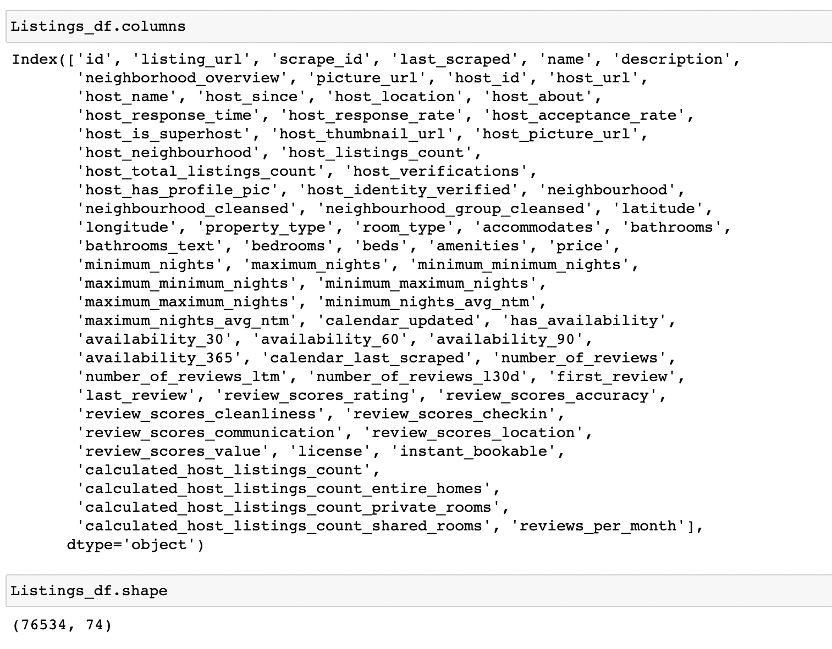

**Reviews File**

The Reviews file has around 1163886 reviews for the Airbnb’s listing in London. There are 6 features in this file as displayed below.

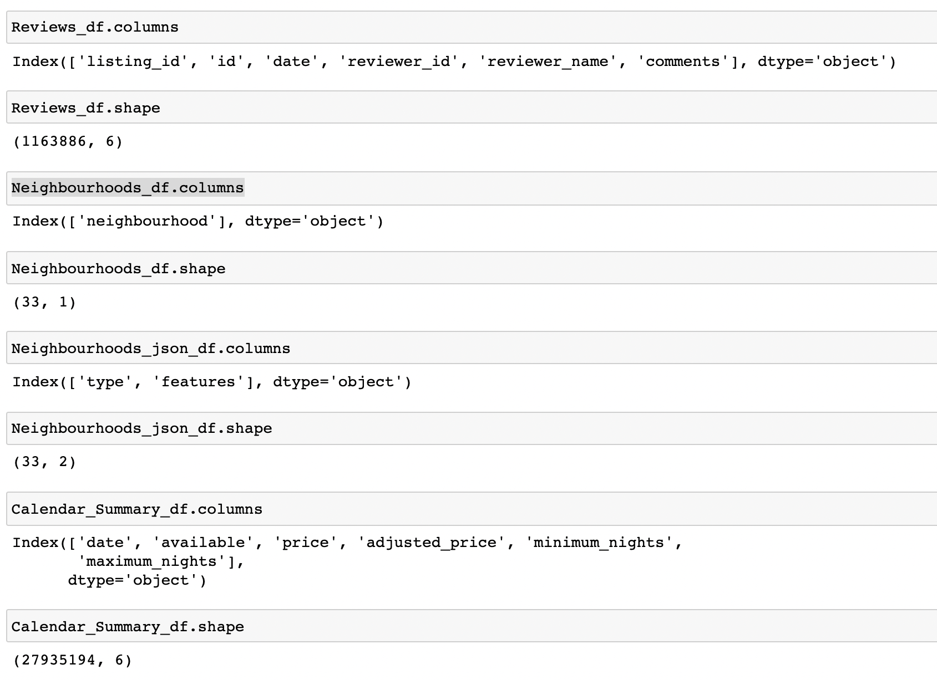

**Neighbourhoods File**

The Neighbourhoods file has around 33 neighbourhoods having the Airbnb listings in London. There is only one feature in this file as displayed below.



**Neighbourhoods Geographical** **File**

The Neighbourhoods geographical file has around 33 neighbourhoods (in terms of latitude and longitude) having the Airbnb listings in London. There are two feature in this file as displayed below.



**Calendar File**



## **Sample Dataset**

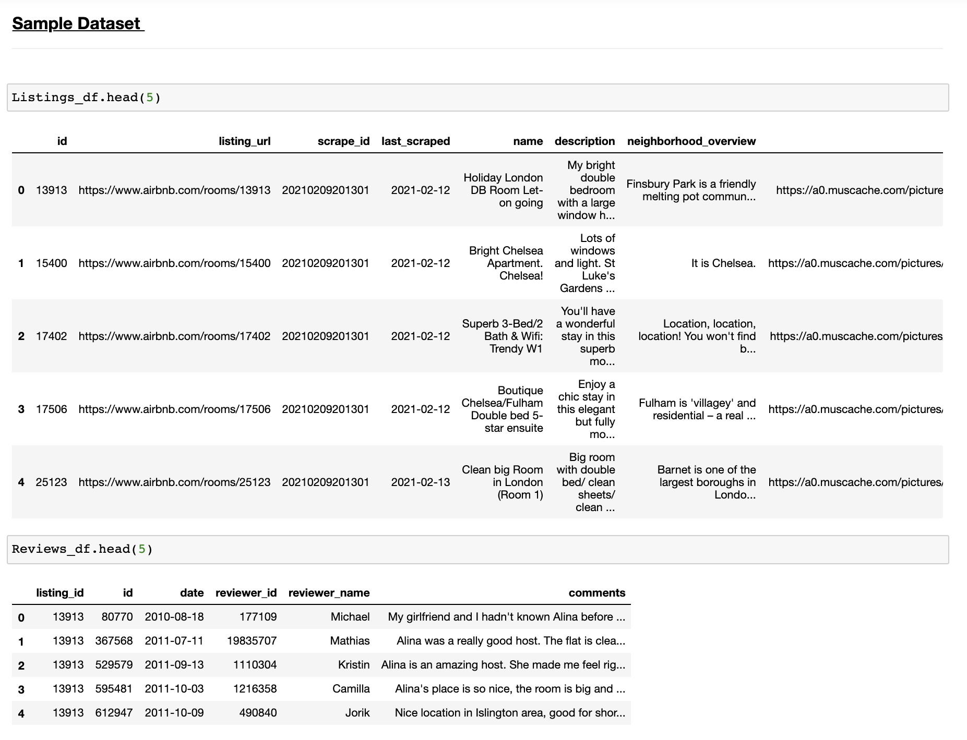



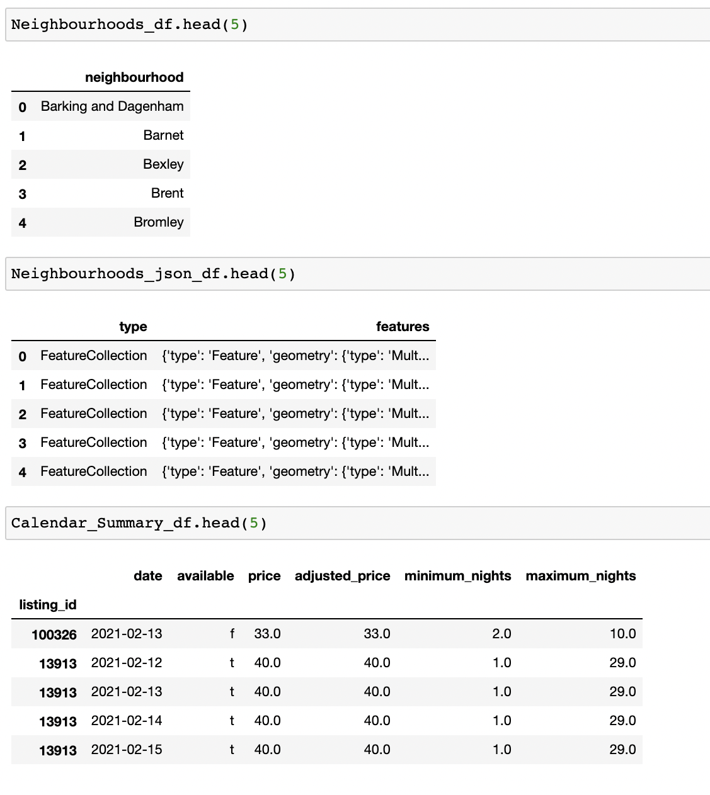

# **Data Cleaning**

## Determining the Null Value data

The listings file has around 24 features having null values. The other files (Reviews, Neighborhoods, Calendar) don’t have the null value data. So, first step is to fix these null value data.

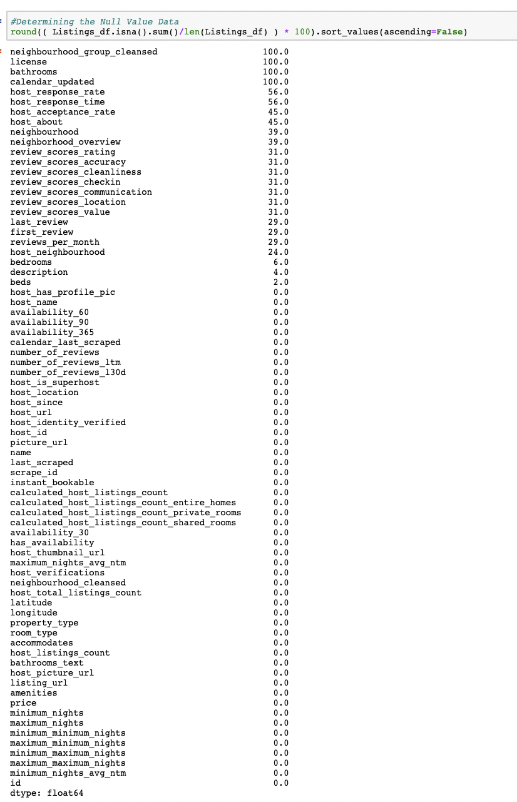

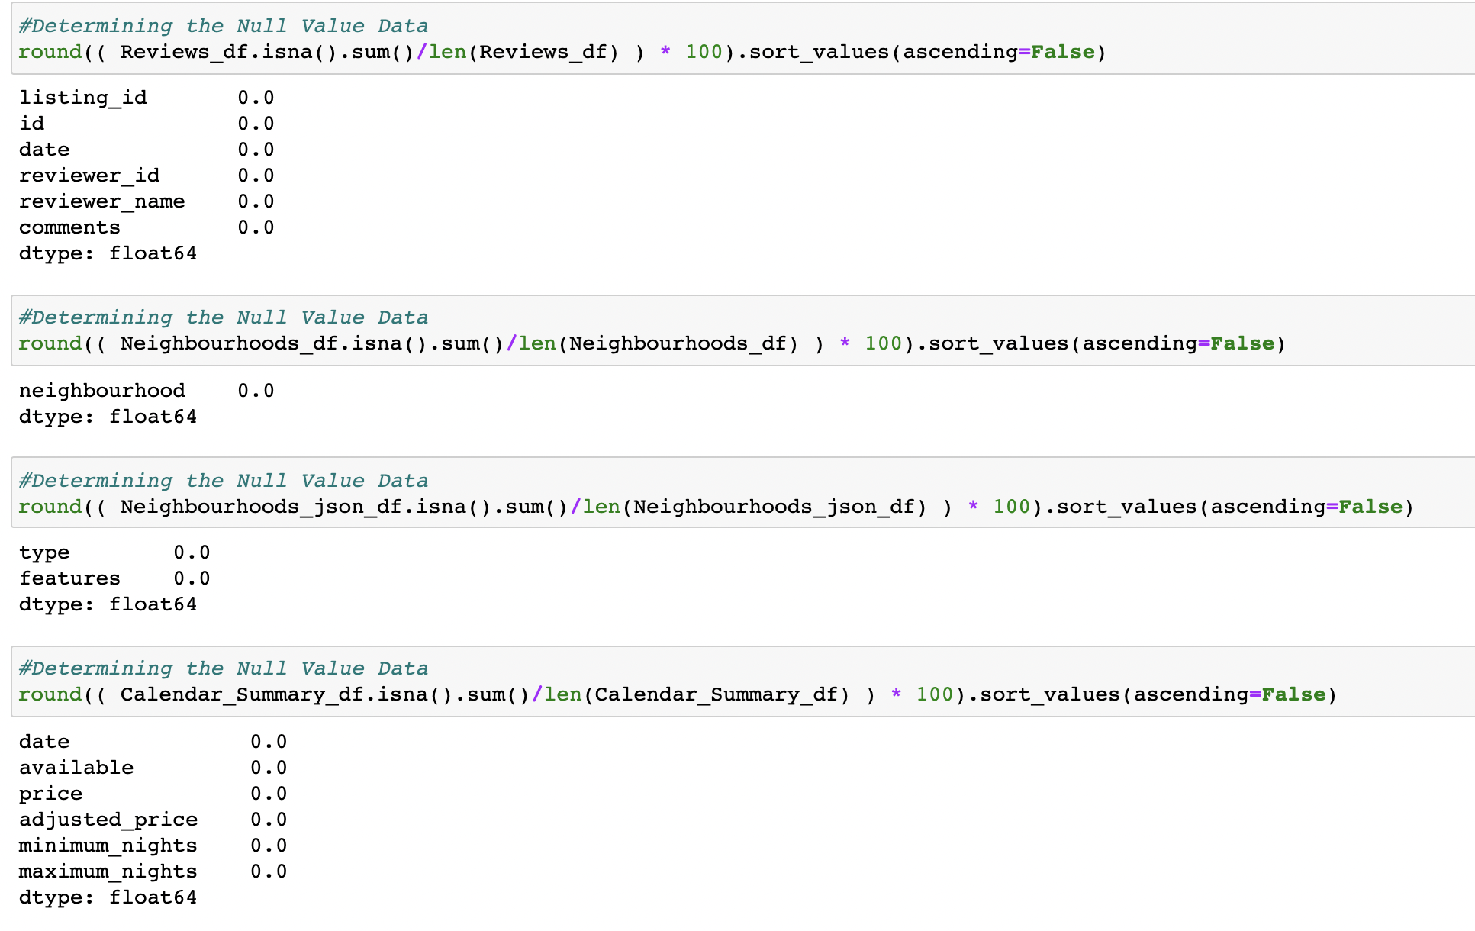

## Dropping the features

The below features have more than 80% of Null Values data (*Looks like there is no data at all for these features*) ; Hence dropping these features.

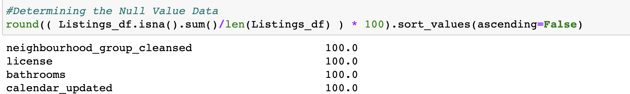



## Converting the Categorical features to Continuous

The bathrooms_text is converted to Continuous feature such that it will be easy to calculate the number of bathrooms. This is done by extracting only the numerical values from the bathroom_text feature.

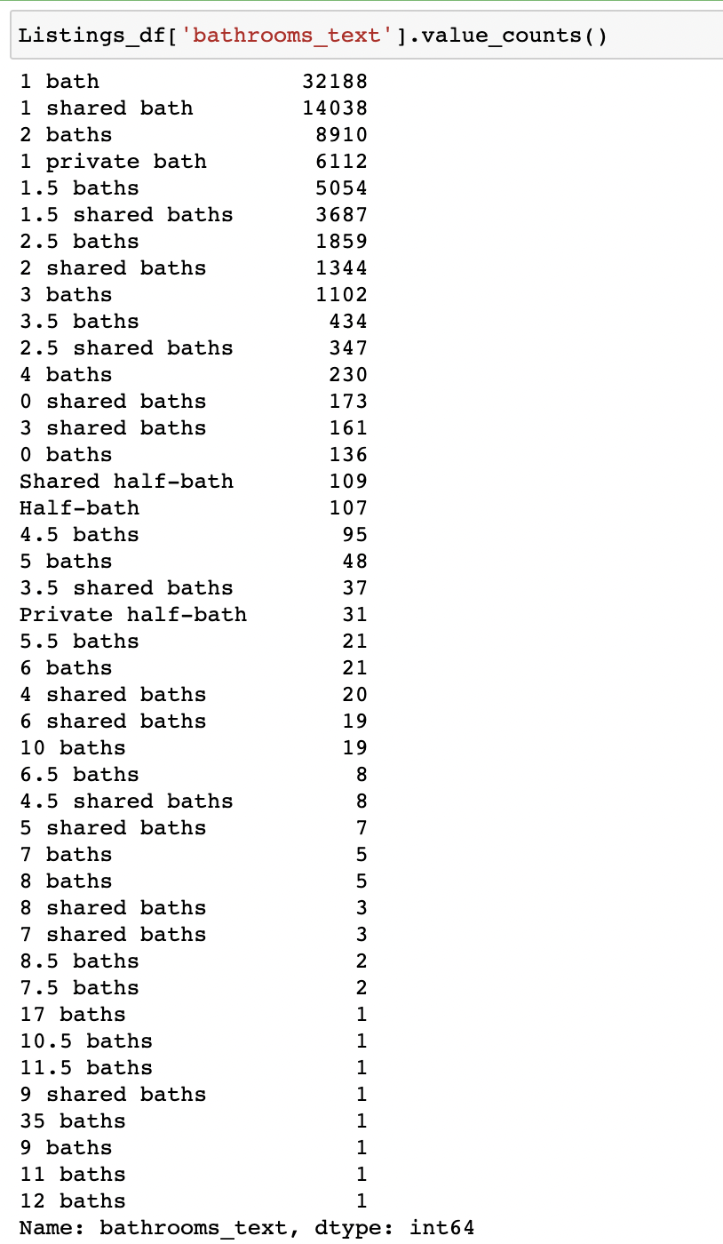

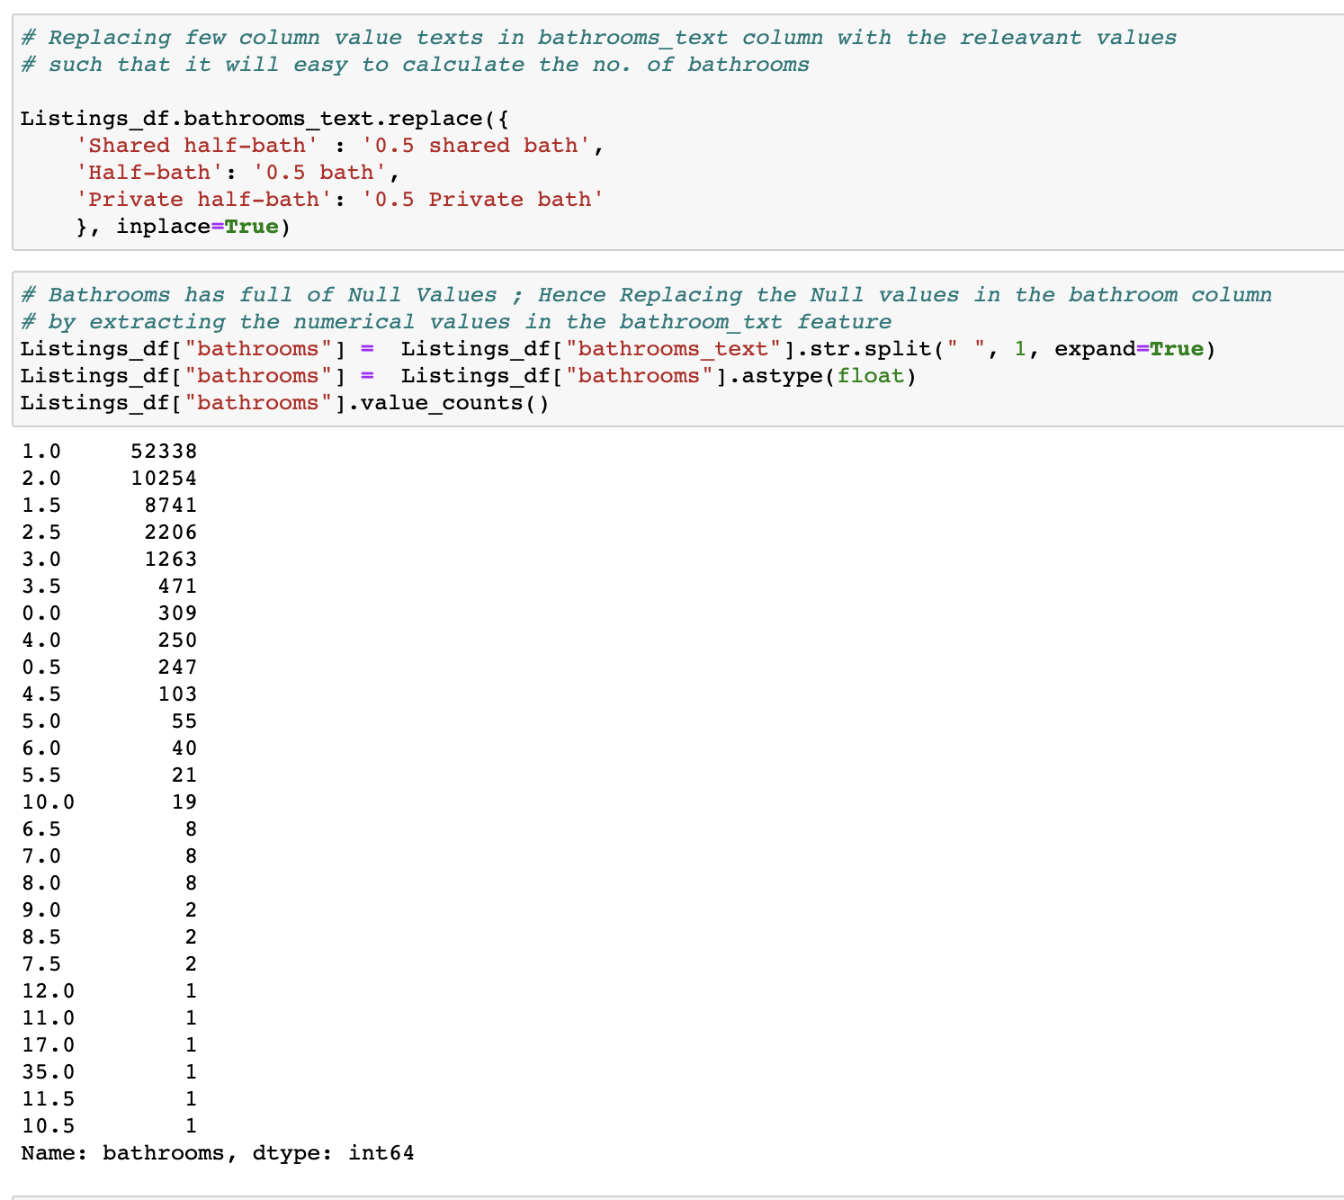

## Dropping Similar Kind of Columns

These features have similar kind of values ; Hence dropping these columns and retaining only one feature for the respective features.

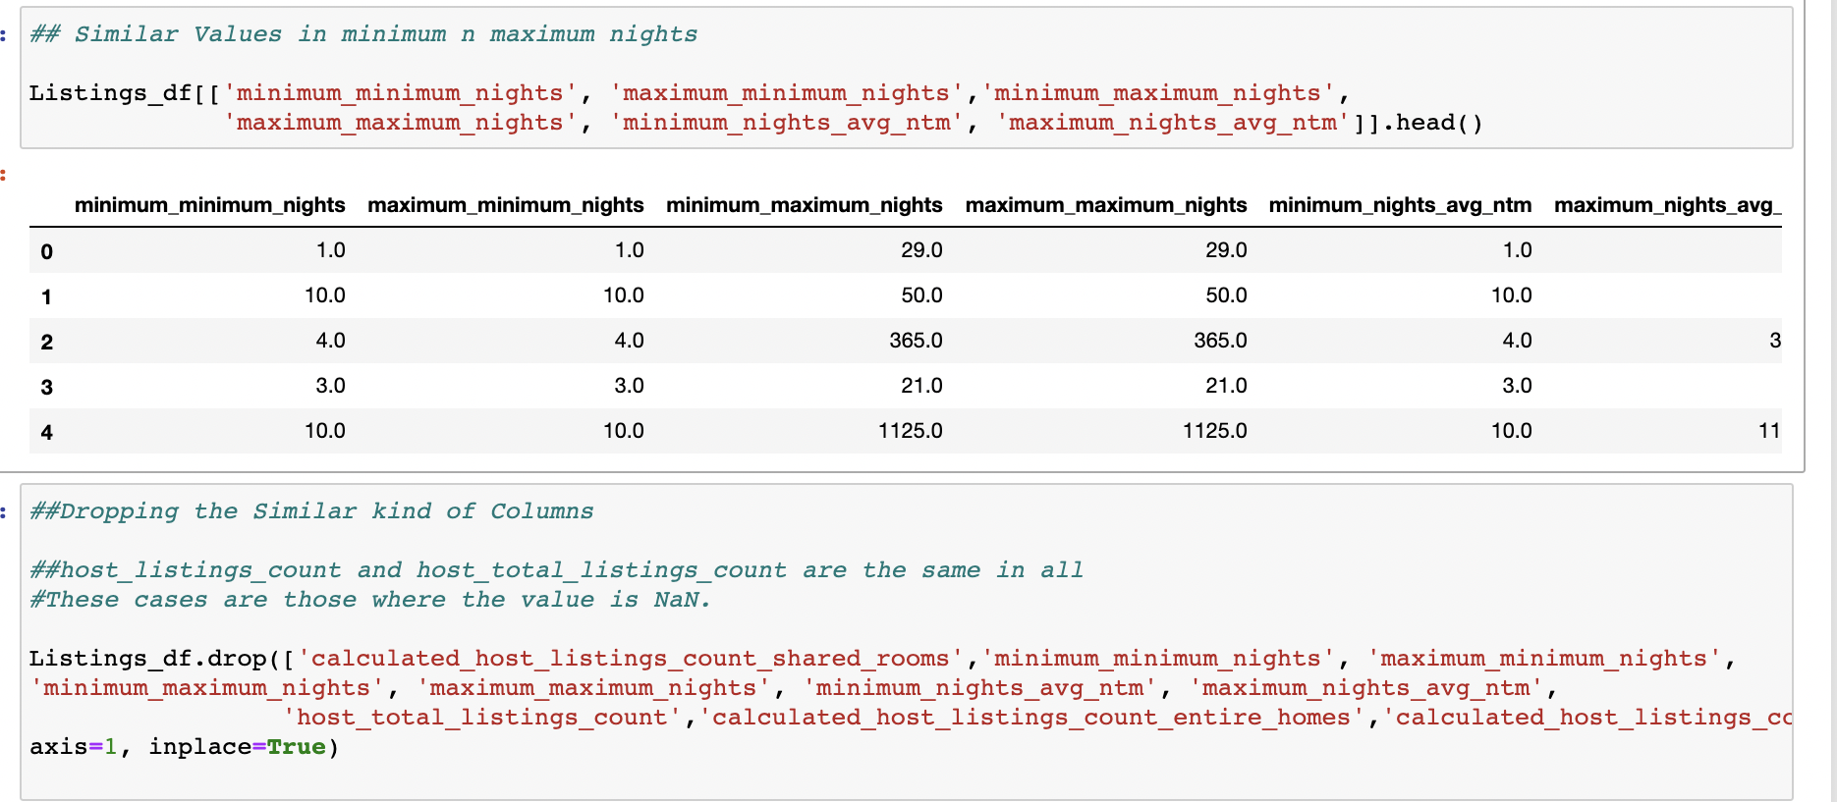

## Replacing Similar kind of Column values

The similar kind of column values is replaced with the respective other column values for a better plot.

**Amenities**

First, the array of object values is split to a single value column; this makes to calculate the amenities count easier. Then irrelevant values were removed and the similar kind of values were replaced with its equivalent values. For example, you can HDTV is replaced with TV. This will make the plot for a better visualization.

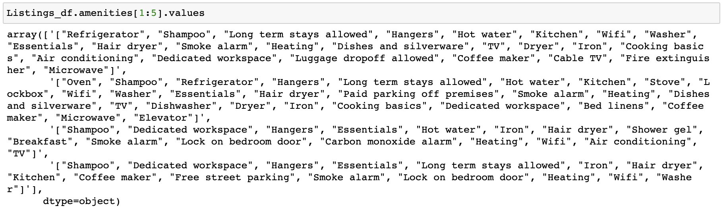

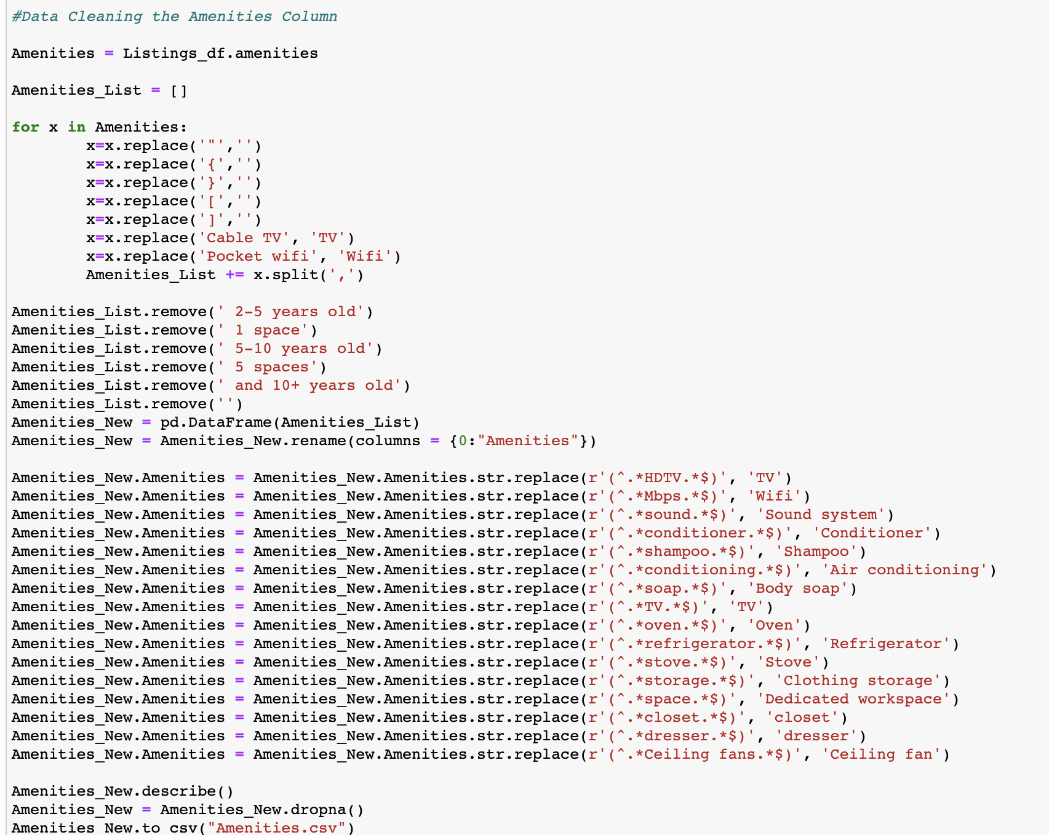

**Property Type**

Similarly, for the property type - the similar kind of values were replaced with its equivalent values. At the end, we just have four property type values; this will make a better-quality visualization.

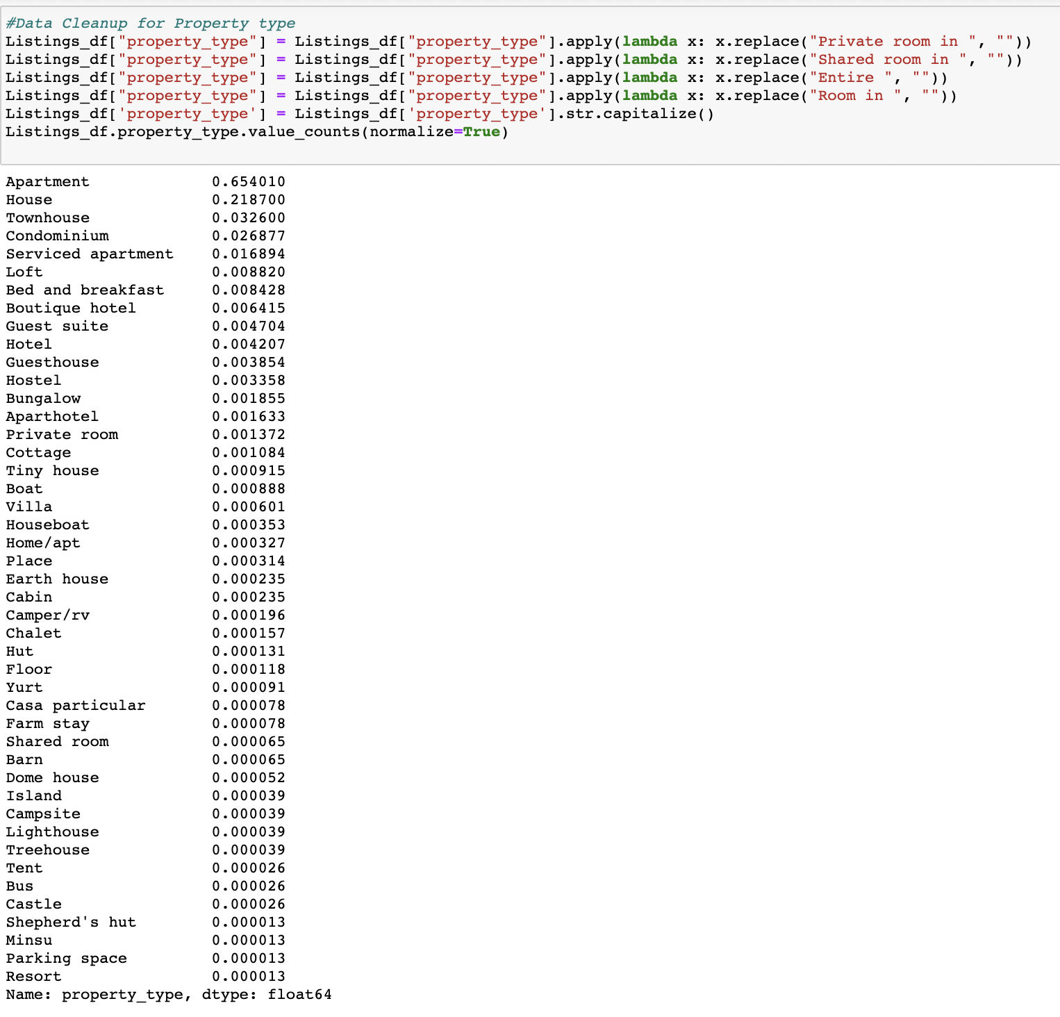

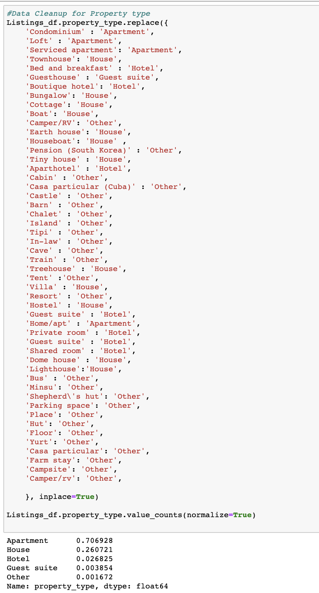

## Changing the Data Types

**First_Review and Host_Since**

For these two features, the data type has been converted to datetime.

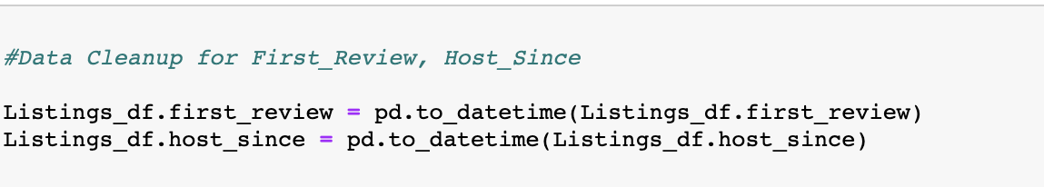

## Removing special characters

**Host Response Rate**

The Host Response Rate column was converted to numeric values by removing the % value in this feature. By doing these it will be easy for calculating the host response rate.

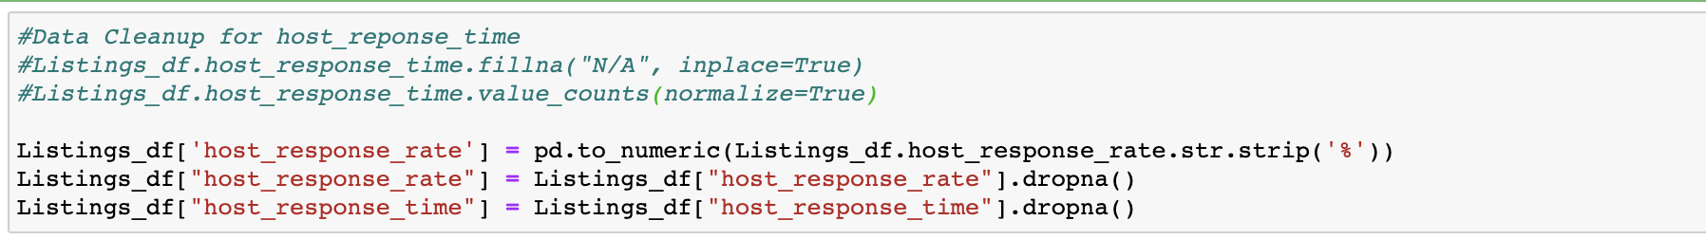

## Dropping Duplicates

Dropping any duplicate rows based on the listing id.



# Dashboard Visualization

***Overview of Airbnb - London***

The first dashboard depicts the “*Overview of Airbnb*” in London. There are around 76534 listings in London. The average rating of the listings is 4.79. There are around 31064 reviews per month. The average rate of the listings is £113.90. There are 33 neighbourhoods in London where the Airbnb’s has been listed. The dashboard displays the below statistics of the Listings in London. These values can be filtered based on each neighbourhood.

* Number of listings
* Average Price
* Average Rating
* Number of Reviews per month
* Hosts



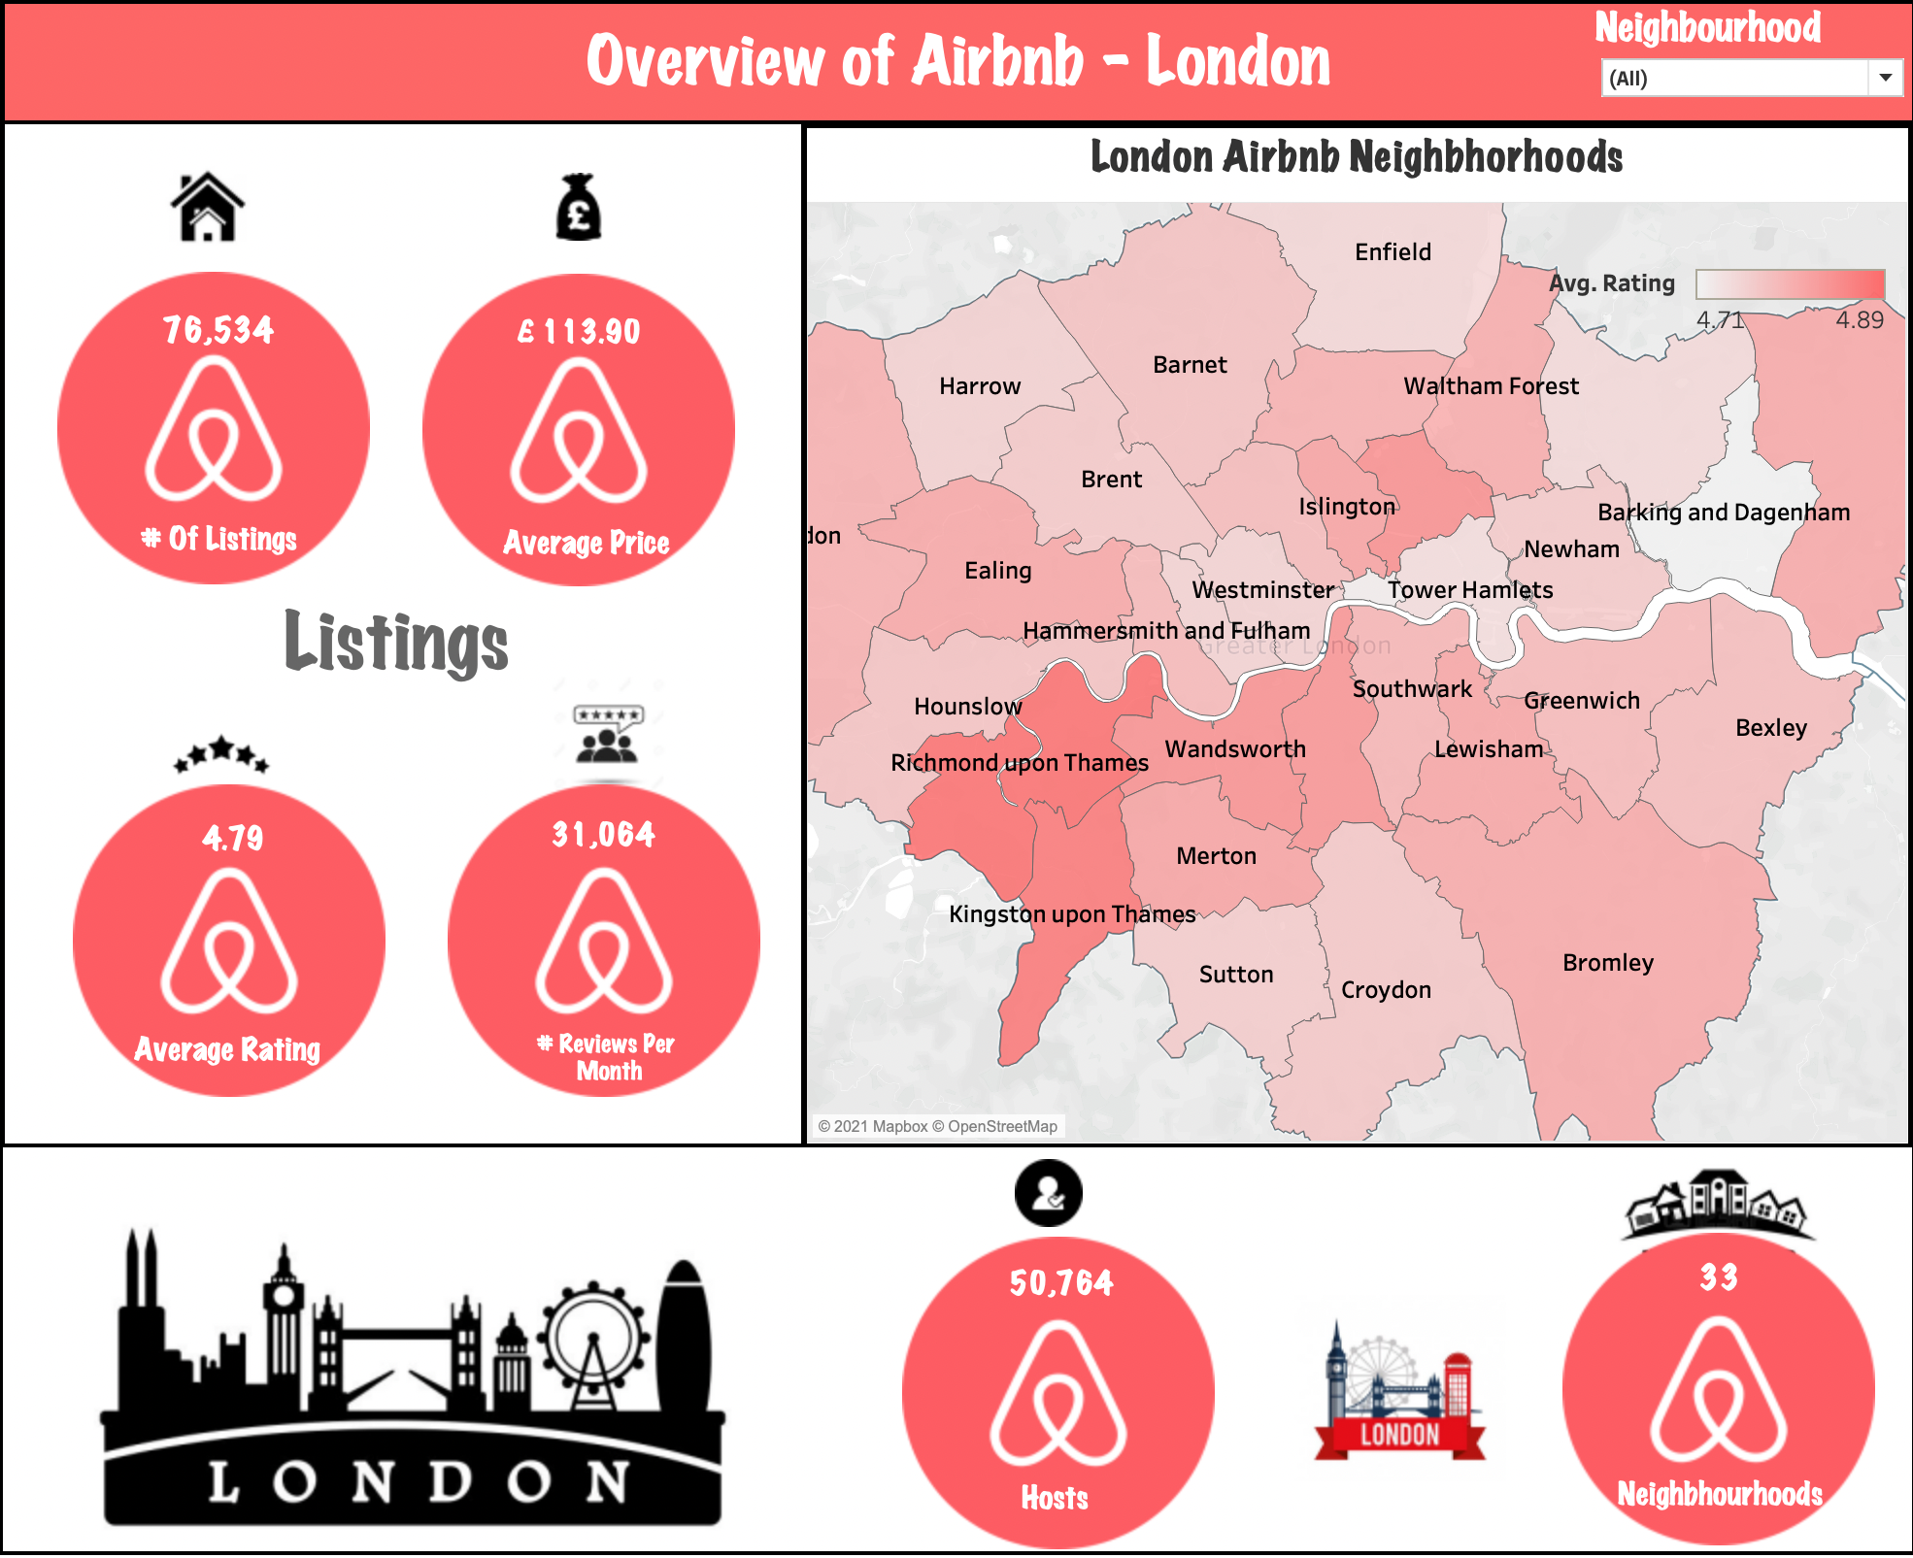

***Listing’s Overview***

The “*Listing’s Overview*” dashboard contains the below three visualizations.

* Yearly Listing’s Count
* Property Type
* Room Type

***Yearly Listing’s Count***

This visualization contains the listing count of London from 2008 to 2021. A line(discrete) graph has been plotted for visualizing this scenario. The x-axis represent the years and y-axis represent the number of listings. The year column has been used in the Pages shelf to break the view into a series of pages by year wise such that we can analyse the listing count year wise. From the graph we can infer that,

* The listings count was increasing as we go from 2008 until 2015, then we see a drop in the listing’s count from 2016 onwards
* In 2020 & 2021, there was drastic drop down on the listing’s count due to the covid pandemic. People were not planning for any vacation during the covid crisis; hence the listings has been reduced drastically.

***Property Type***

This visualization contains the statistics details of the Property Type. A pie chart has been plotted to visualize the Property Type details. From the Graph we can infer that,

* There are four categories of property types : Apartment, House, Guest Suit and Other
* Most of the Airbnb Property types in London belongs to Apartment of about 70.69% followed by House of about 26.07%

***Room Type***

This visualization contains the statistics details of the Room Type. A pie chart has been plotted to visualize the Room Type details. From the Graph we can infer that,

* There are four categories of Room types : Entire home/apt, Private room, Shared room, Hotel room
* Most of the Airbnb Room types in London belongs to Entire home/apt of about 54.40% followed by Private room of about 44.08%



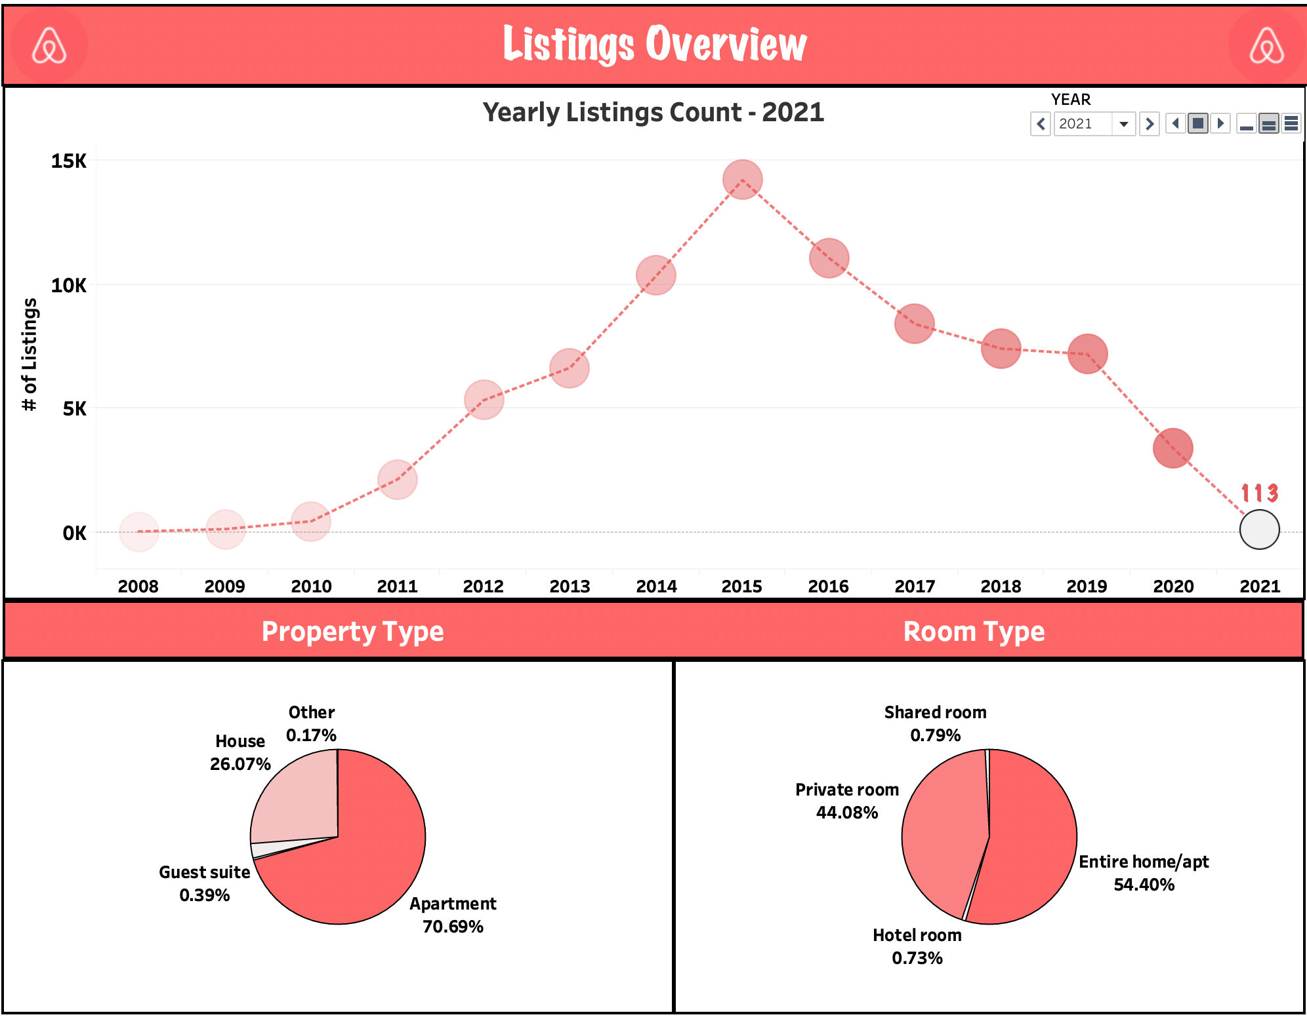

***When to Plan for Vacation?***

The “*When to Plan for Vacation?*” dashboard contains the below two visualizations.

* Finding Busiest Month
* Most/Least Expensive Time to visit London

***Finding the Busiest Month***

This visualization helps in determining the peak vacation month in London. A line(discrete) chart has been plotted for visualizing this scenario. The x-axis represent the Month and y-axis represent the Average availability. From the Graph we can infer that,

* The peak vacation month is seems to be May since you can see the average availability of getting a property is very less.
* March month being the off-season to travel London
* Looks like best time to visit London is during their summer season (April – June)
* To plan a trip for a cheaper accommodations (time when less people travel)

***Most/Least Expensive Time to Visit London***

This visualization contains the average price range for each weekday – Month wise. A highlighting tables has been plotted to visualize this scenario. From the tables we can infer that,

* The rates starts to increase from May throughout December month. December being the costliest month
* To plan a trip for a cheaper accommodations (time when the average price is less)

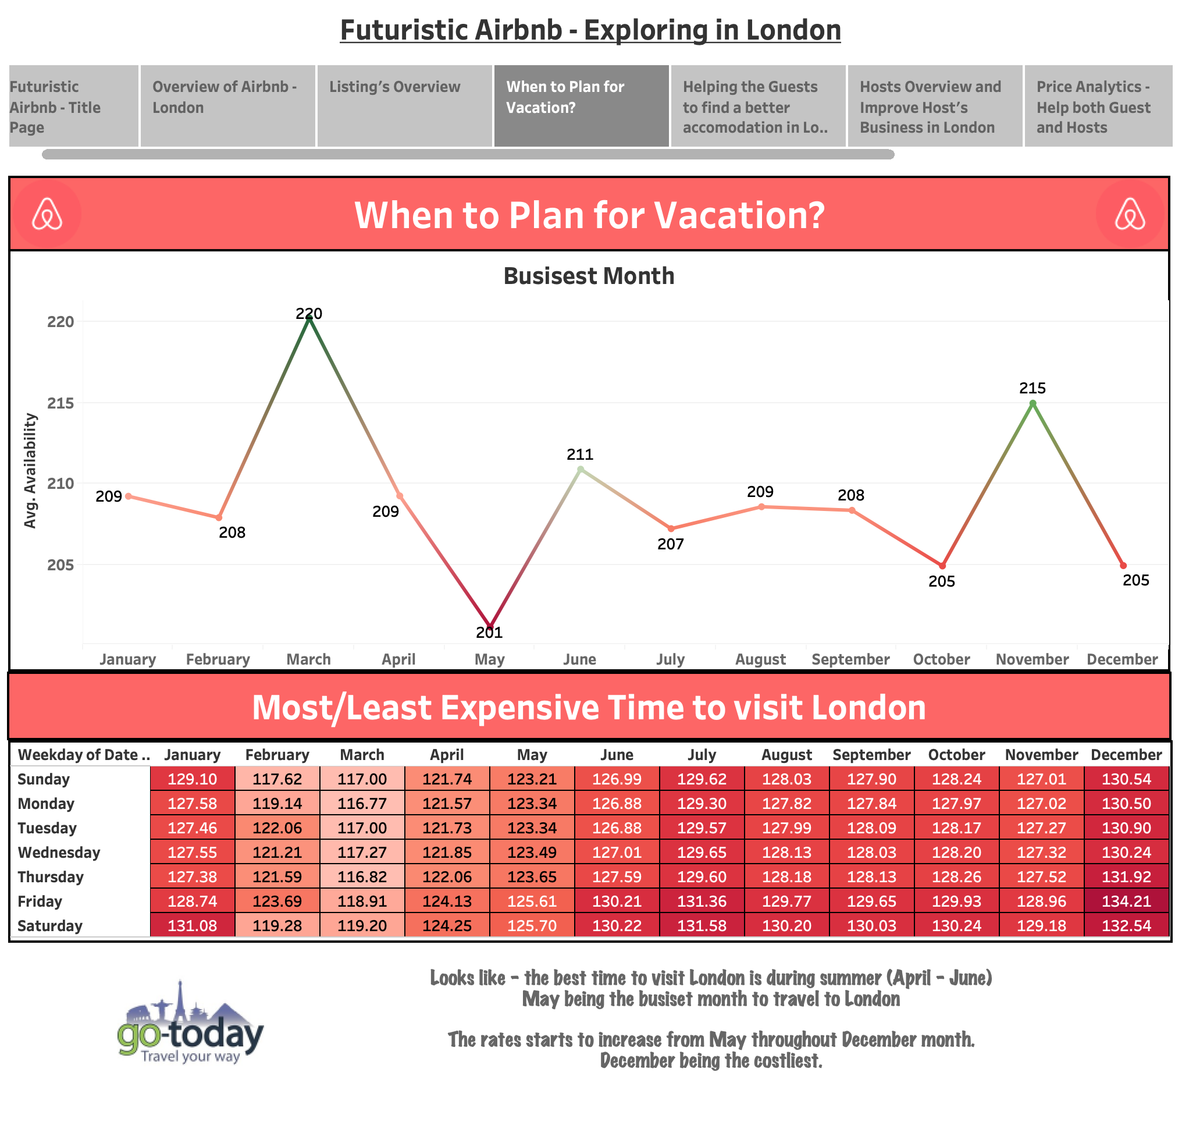

***Airbnb’s Listing in London***

The dashboard depicts the “*Airbnb’s Listings*” in London which helps in finding a better accommodation in London. It visualizes the Listings using the map visualization – Neighbourhood wise (at a time only one neighbourhood listing’s will be displayed on the map for a better visualization). The map can be filtered based on Neighbourhood, Room Type, and Price Range. Once the required listing is selected on the map; the dashboard will display the following statistics based on the property chosen.

* Minimum and Maximum Nights
* Bathrooms
* Accommodates
* Bedrooms
* Beds
* Price
* Ratings
* Review
* Property Image



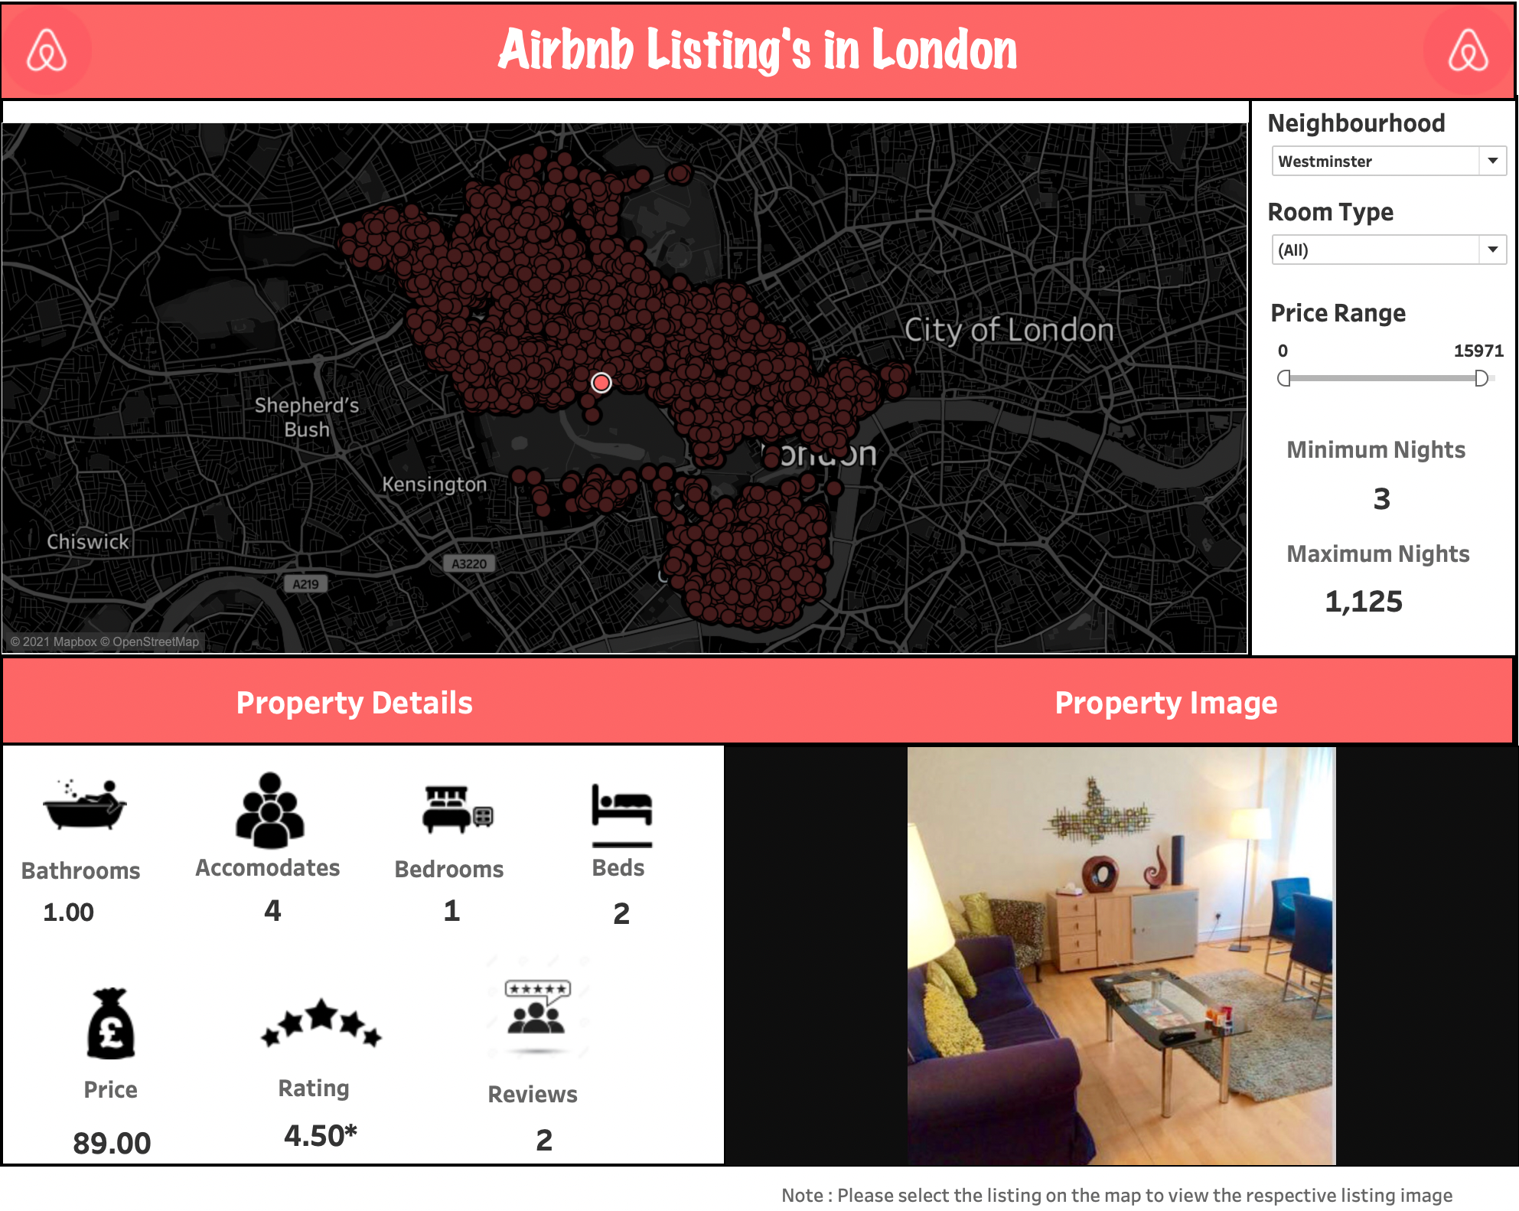

***Hosting’s Overview and Improve Host Business in London***

The “*Hosting’s Overview and Improve Host Business in London*” dashboard contains the below five visualizations.

* Hosts joining Airbnb
* Host Response Time
* Judging Host Response and Host Acceptance Rate based on Super host
* Host Verification
* Top 10 Amenities

***Host joining Airbnb***

This visualization contains the number of hosts joining London Airbnb from 2008 to 2021. A line(discrete) graph has been plotted for visualizing this scenario. The x-axis represent the years and y-axis represent the number of listings. The year column has been used in the Pages shelf to break the view into a series of pages by year wise such that we can analyse the hosting count year wise. From the graph we can infer that,

* The hosts joining Airbnb count was increasing as we go from 2008 until 2015, then we see a drop in the listing’s count from 2016 onwards
* In 2020 & 2021, there was drastic drop down on the hosts count due to the covid pandemic. People were not planning for any vacation during the covid crisis; hence the hosts joining and putting listings on Airbnb has been reduced drastically.

***Host Response Time***

This visualization contains the statistics on the Host Response Time. A bar chart has been plotted for visualizing this scenario. The x-axis represent the Host Response Time values and y-axis represent the Count of hosts. From the Graph we can infer that,

* About 51% of the hosts reply within an hours and 20% of the hosts reply within few hours.
* From the Guest Perspective, For knowing about the best hosts for ease of communication
* From the Host Perspective, For improving their response rate to further to attract the customers

***Judging Host Response and Host Acceptance Rate based on Super host***

This visualization displays the Average Host Response and Host Acceptance Rate. A scatter plots has been designed to visualize these rates percentage based on the Super Host feature. From the Graph we can infer that,

* Super Hosts Average Response Rate % (96.38%) is more than the normal hosts (82.88%)
* Super Hosts Average Acceptance Rate % (87.65%) is more than the normal hosts (80.91%)

***Host Verification***

This visualization contains the status of the Host Verification whether the host has been verified or not. A pie chart has been plotted to visualize the Host Verification feature. From the Graph we can infer that,

* Around 76.67% of hosts have been verified. Verifying the details is something hosts often think they are expected to do
* Guests might expect the additional trust commanded by verified hosts for their accommodation

***Top 10 Amenities***

This visualization contains the Top 10 Amenities – Wifi, Washer, TV, Smoke alarm, Kitchen, Iron, Heating, Hangers, Hair dryers, and Essentials . A text table using the mark *Circle* has been plotted to visualize the Top 10 Amenities of the properties. From the Graph we can infer that,

* Wi-Fi, Heating, Essentials, Kitchen and Washer are the most important amenities to be considered for the successful of listing.
* For those who are already in the business and don't have those amenities, make sure the facility of installing all or some of the amenities to grow your business



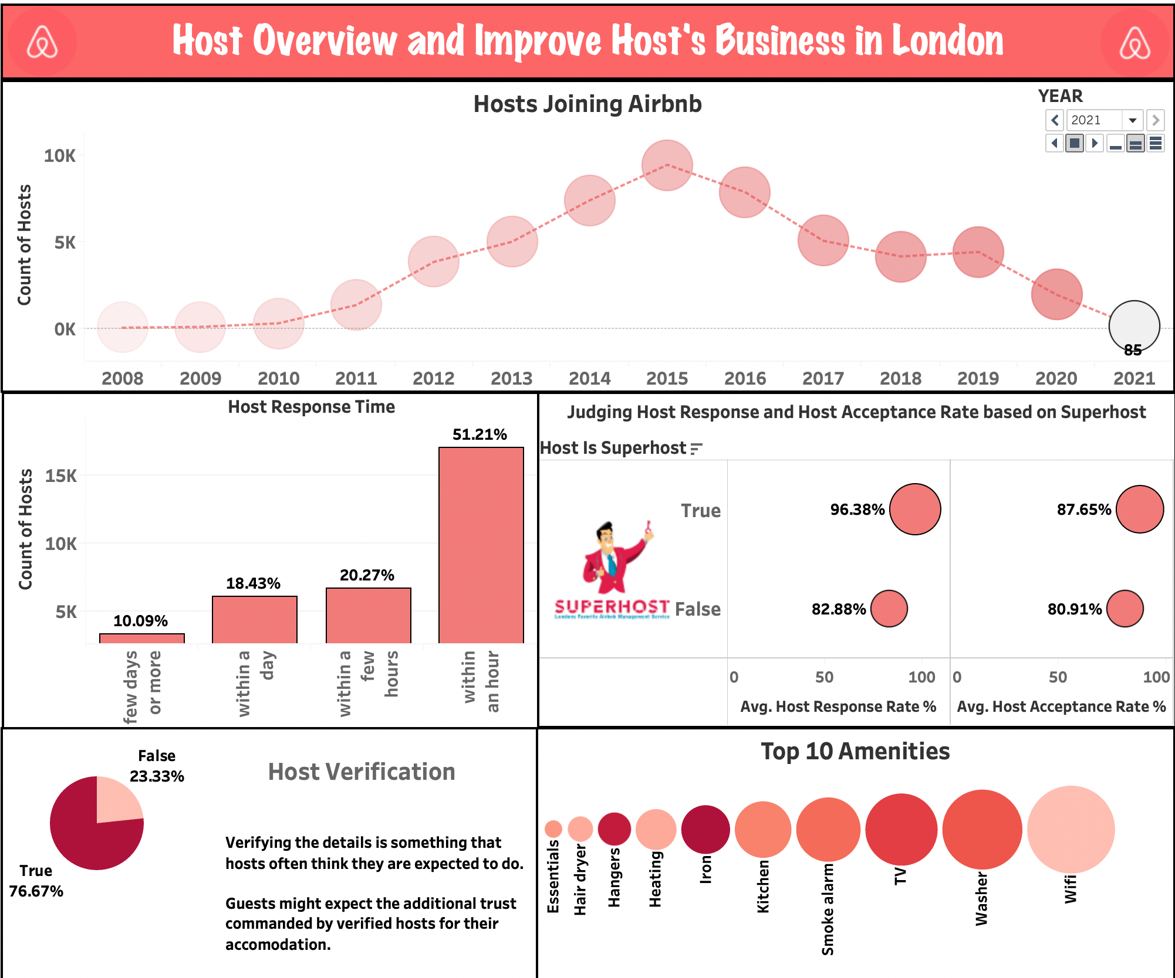

***Price Analytics***

The “*Price Analytics*” dashboard contains the below three visualizations.

* How have prices changed over time?
* Accommodates vs Average Price
* Future Price Prediction based on Room Type

***How have prices changed over time?***

This visualization shows the average price range change from 2008 to 2021. A line(discrete) graph has been plotted for visualizing this scenario. The x-axis represent the years and y-axis represent the average price. From the graph we can infer that,

* The average price has been keep on fluctuating – going up and down throughout the years
* In 2019, the average price of the listing was high around £115.07. But in 2021 the listing price dropped to £84.56 due to the covid pandemic. People were not planning for any vacation during the covid crisis; hence the listings price has been reduced drastically.

***Accommodates Vs Average Price***

This visualization shows the average price based on the accommodates. A line(discrete) graph has been plotted for visualizing this scenario. The x-axis represent the accommodates and y-axis represent the average price. From the graph we can infer that,

* It is evident that - As the accommodates increases, the average prices also increases
* Though, there was a drop on the average price for the accommodates 13 and 15. ( almost £100 difference range )

***Future Price Prediction based on Room Type***

This visualization shows the future price prediction based on the Room Type. A box and whisker plot has been designed for visualizing this scenario. The x-axis represent the current and the future year. The y-axis represent the average price. From the graph we can infer that,

* For the Guest Suite and the House Room type, the future predicted price is almost same for the year 2021 and 2022.
* For the Apartment Room type, there is a slight increase in the future predicted price of about £3
* For the Hotel Room type, the future predicted price is around £180.53 which is like a huge increase of about £17

***Most Expensive Properties and Neighbourhoods***

This dashboard displays the most expensive properties and Neighbourhoods of London. The top 5 expensive properties is plotted using the bar charts. The x-axis represent the properties name and the y-axis represent the average price. From the Graph, we can infer that the top 5 properties are – *Thames Historic 1920s House, Mulberry Flats, F2 Greek Street, F1 Greek Street, and Eldon Chamber Flats*. The Property images also displayed in the dashboard when we select the property. The expensive Neighbourhoods is plotted using the map visualizations based on the average price feature. The more darker the place (highlighted in red) ; the more expensive the place it. From the Average Price – Neighbourhood Map visualization, we can infer that City of London is the most expensive neighbourhood of about £258.1 rate followed by Westminster of about £183.5 rate.



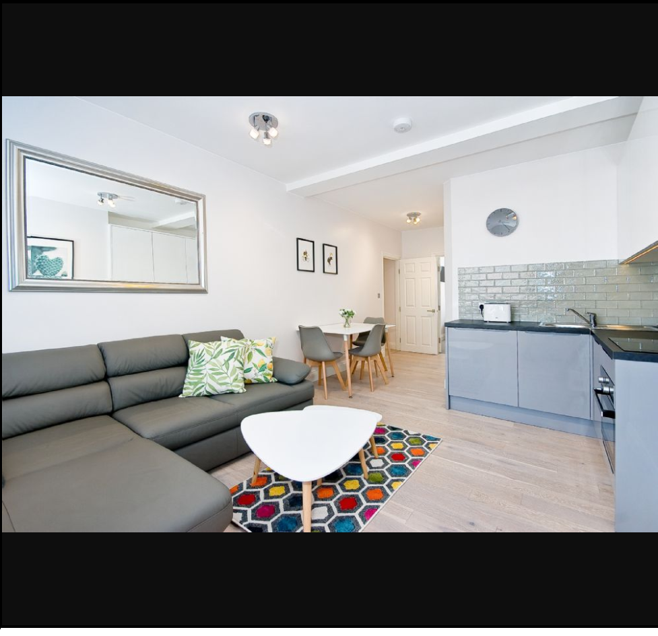

# Takeaways

# Conclusion & Future Work

# References

<http://insideairbnb.com/get-the-data.html>

https://help.tableau.com/current/pro/desktop/en-us/buildmanual_shelves.htm